**Phase 3: Data Modeling & Relationships**

**Project:** Smart Internship & Placement Management System

**1. Objective**

To create and configure custom objects, fields, relationships, page layouts, compact layouts, tabs, related lists, and sample data for managing companies, students, internships, applications, and feedbacks in Salesforce.

**2. Custom Objects Creation**

**Procedure:**

1. Navigate: **Setup → Object Manager → Create → Custom Object**
2. Enter object details (Label, Plural Label, Record Name, Data Type, API Name).
3. Check options: **Allow Reports**, **Allow Activities**, **Track Field History**.
4. Click **Save**.

| **Object** | **Label** | **Plural Label** | **API Name** | **Record Name** | **Data Type** |
| --- | --- | --- | --- | --- | --- |
| Company | Company | Companies | Company | Name | Text (80) |
| Student | Student | Students | Student | Name | Text (80) |
| Internship | Internship | Internships | Internship | Name | Text (120) |
| Application | Application | Applications | Application | Name | Auto Number (APP- {0000}) |
| Feedback | Feedback | Feedbacks | Feedback | Name | Auto Number (FB- {0000}) |

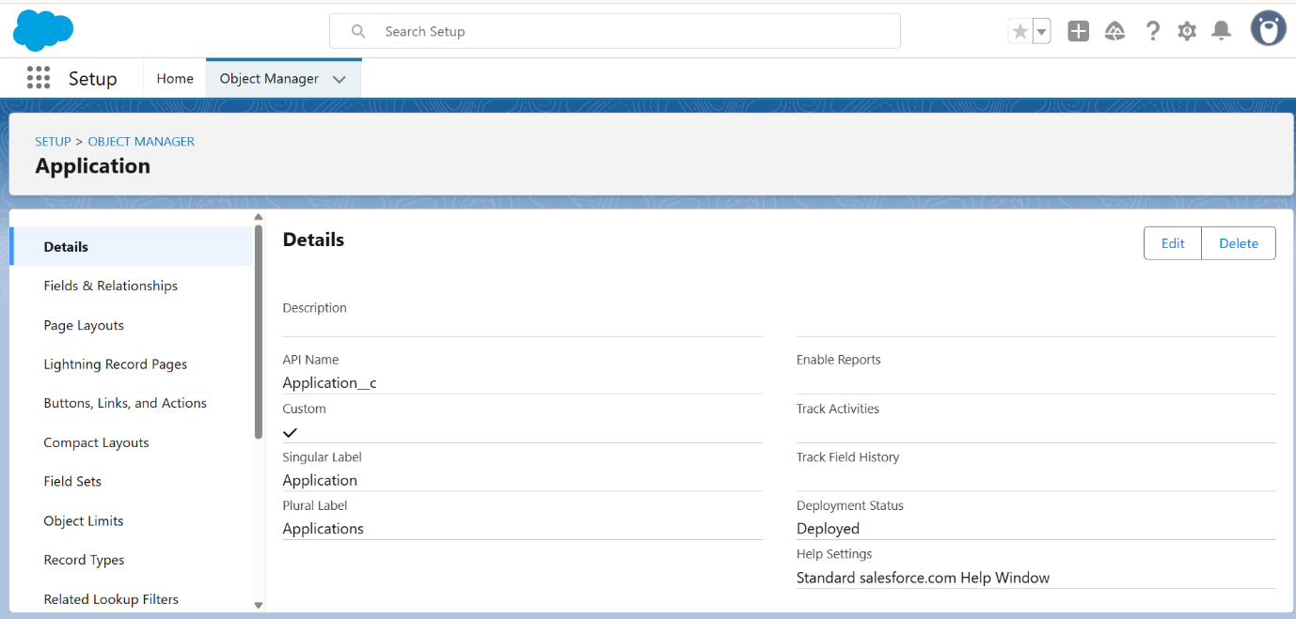  
  
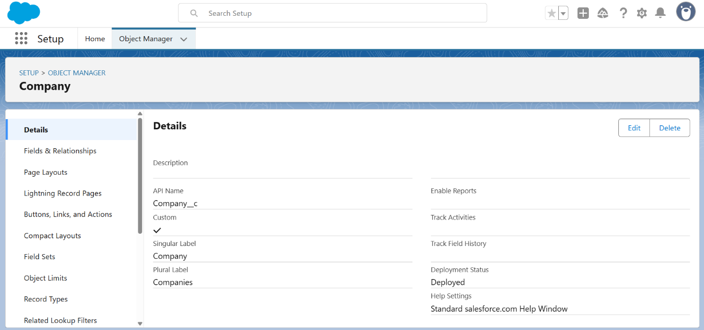  
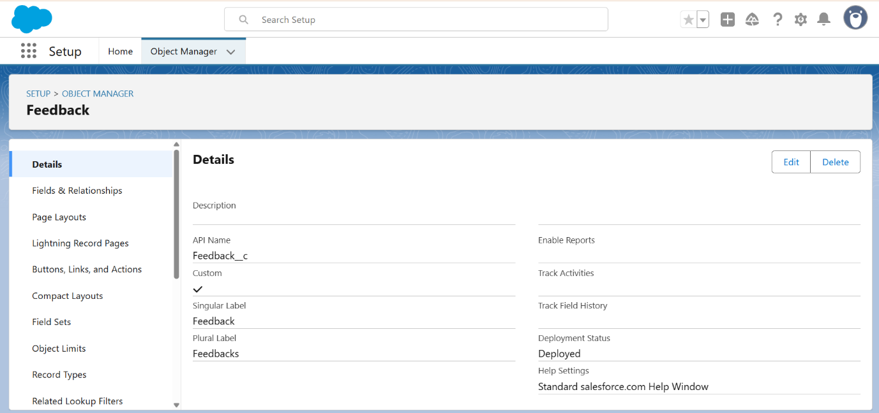  
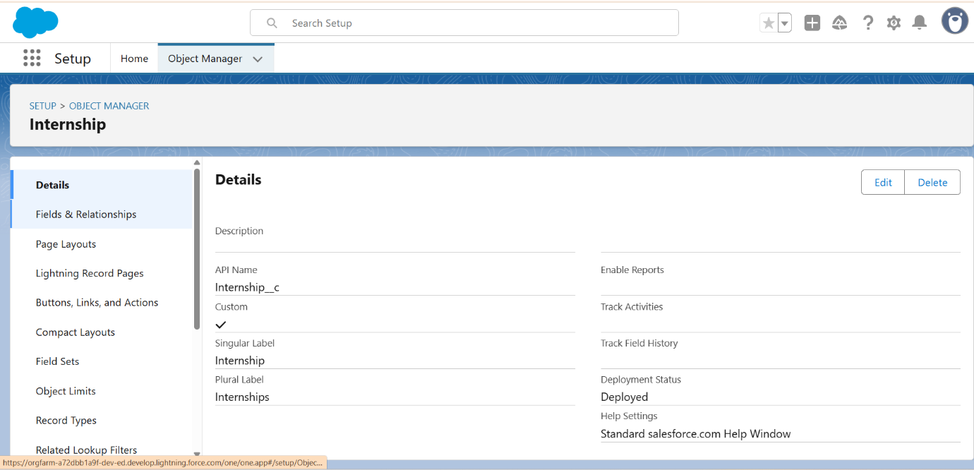  
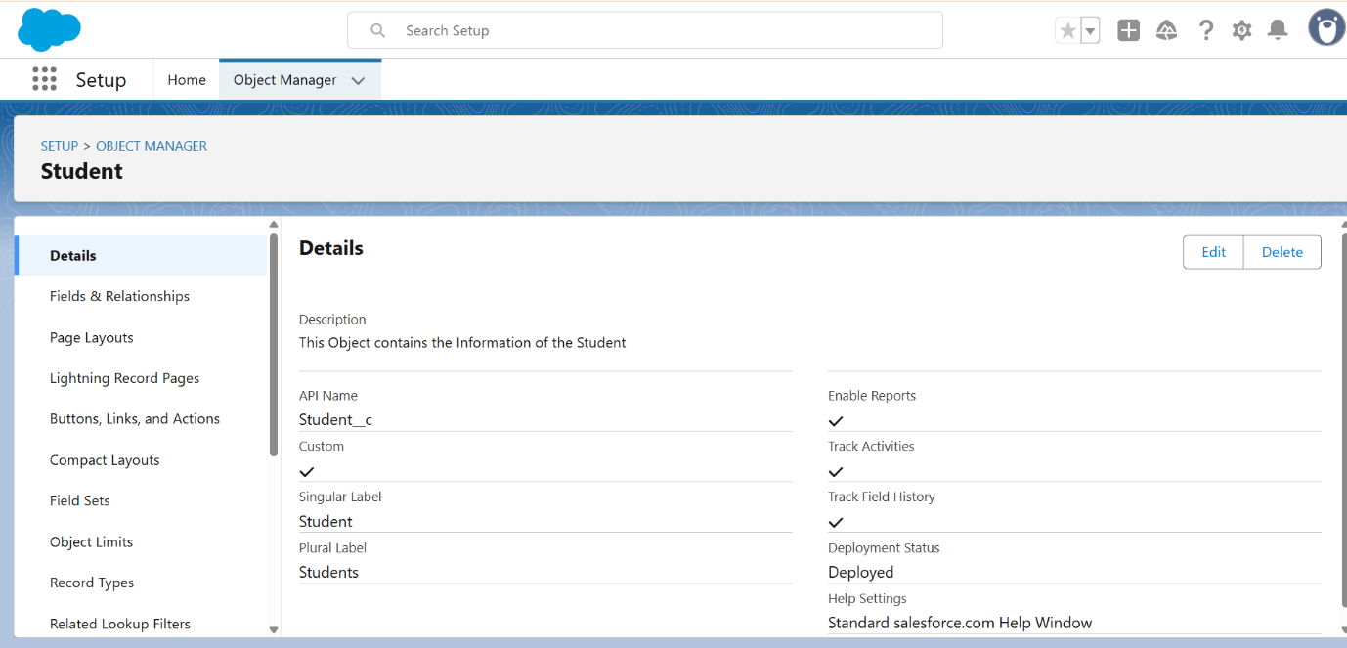

**3. Fields & Relationships**

**3.1 Company__c Fields**

**Procedure:**

1. Object Manager → Company → Fields & Relationships → New
2. Choose data type → Next → Enter field details → Next → Set Field-Level Security → Add to Page Layout → Save

| **Field Label** | **API Name** | **Type** | **Notes** |
| --- | --- | --- | --- |
| HR Contact Person | HR_Name__c | Text (50) | Optional |
| HR Email | HR_Email__c | Email | Optional |
| HR Phone | HR_Phone__c | Phone | Optional |
| Industry | Industry__c | Picklist | IT, Banking, Consulting, Manufacturing |

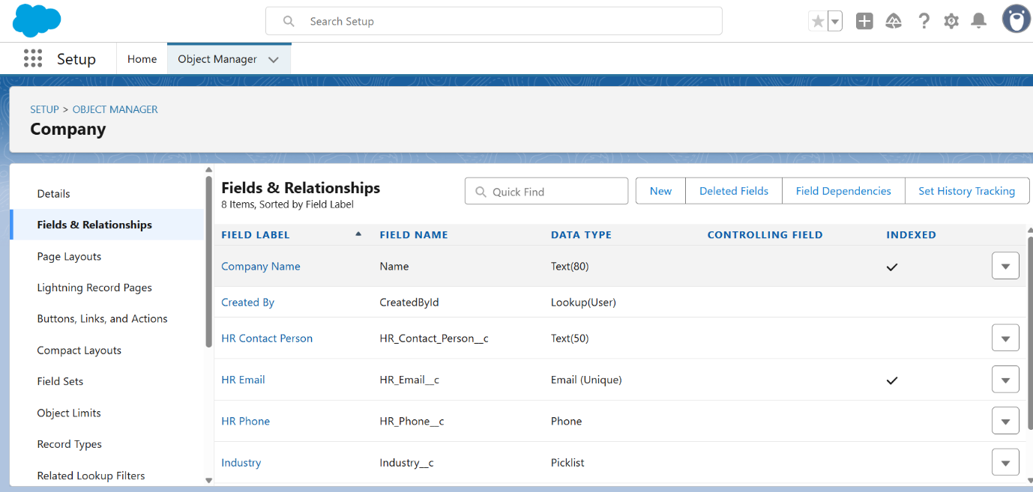

**3.2 Student__c Fields**

**Procedure:** Same as above

| **Field Label** | **API Name** | **Type** | **Notes** |
| --- | --- | --- | --- |
| Roll Number | Roll_No__c | Text (10) | Optional, Unique if needed |
| Department | Department__c | Picklist | CSE, ECE, MECH, CIVIL, MBA |
| Year | Year__c | Picklist | 1st, 2nd, 3rd, 4th |
| CGPA | CGPA__c | Number (3,2) | Optional |
| Email | Email__c | Email | Optional |
| Phone | Phone__c | Phone | Optional |

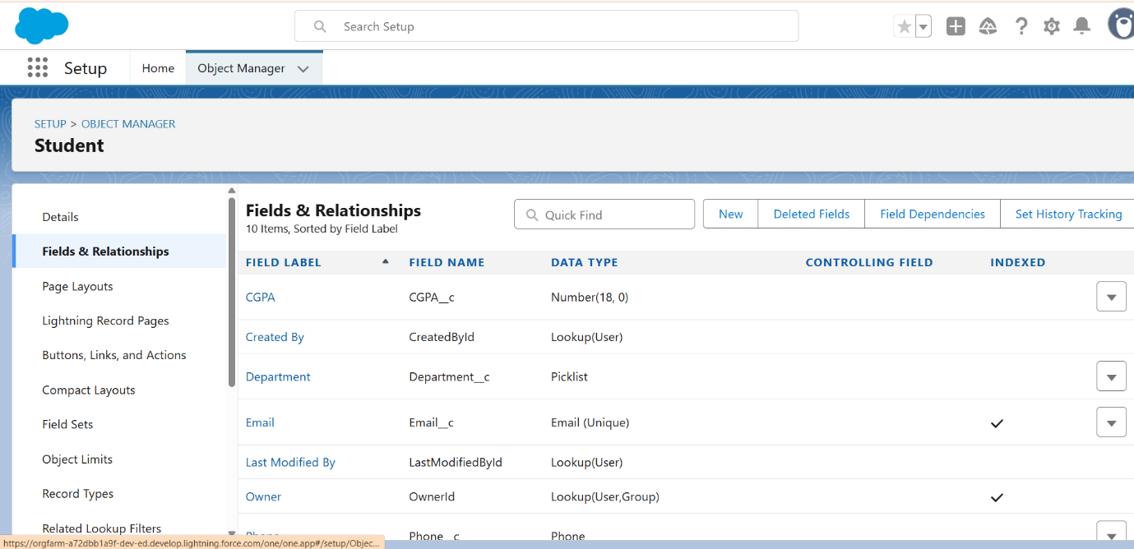

**3.3 Internship__c Fields**

| **Field Label** | **API Name** | **Type** | **Notes** |
| --- | --- | --- | --- |
| Company | Company__c | Lookup (Company) | Required |
| Duration | Duration__c | Text (30) | Optional |
| Stipend | Stipend__c | Currency (10,2) | Optional |
| Location | Location__c | Text (50) | Optional |
| Start Date | Start_Date__c | Date | Optional |
| End Date | End_Date__c | Date | Optional |

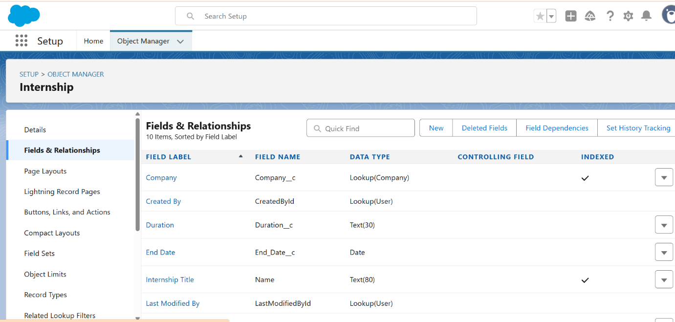

**3.4 Application__c Fields**

| **Field Label** | **API Name** | **Type** | **Notes** |
| --- | --- | --- | --- |
| Student | Student__c | Lookup (Student) | Required |
| Internship | Internship__c | Lookup (Internship) | Required |
| Status | Status__c | Picklist | Applied, Approved, Rejected, Selected, Completed |
| Application Date | Application_Date__c | Date | Default: Today |
| Remarks | Remarks__c | Text Area (255) | Optional |

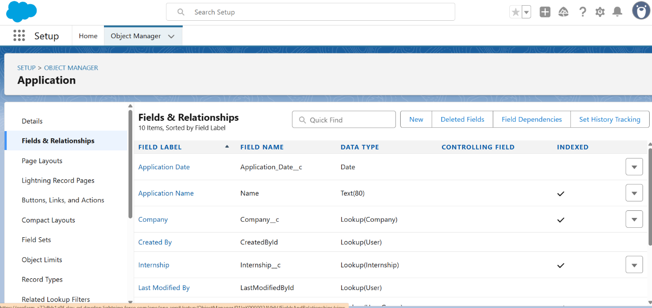

**3.5 Feedback__c Fields**

| **Field Label** | **API Name** | **Type** | **Notes** |
| --- | --- | --- | --- |
| Student | Student__c | Lookup (Student) | Required |
| Company | Company__c | Lookup (Company) | Required |
| Rating | Rating__c | Number (1,0) | Optional |
| Comments | Comments__c | Long Text Area (1000) | Optional |
| Date Given | Feedback_Date__c | Date | Optional |

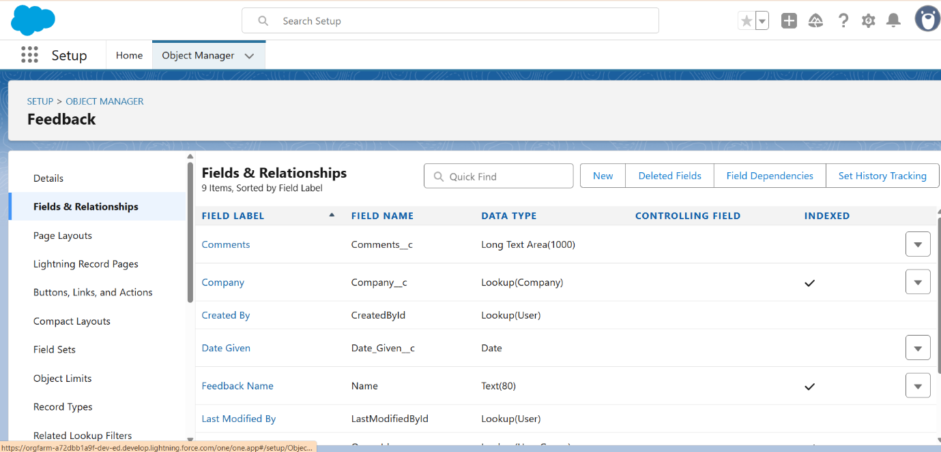

**4. Field-Level Security & Required Settings**

**Procedure:**

1. While creating fields, click **Next → Field-Level Security**
2. Ensure **System Administrator** visibility is checked
3. Set visibility for HR/Student profiles as needed
4. Check **Add to Page Layout** → Save

**Tip:** Hide CGPA for HR profile if sensitive.  
  
  
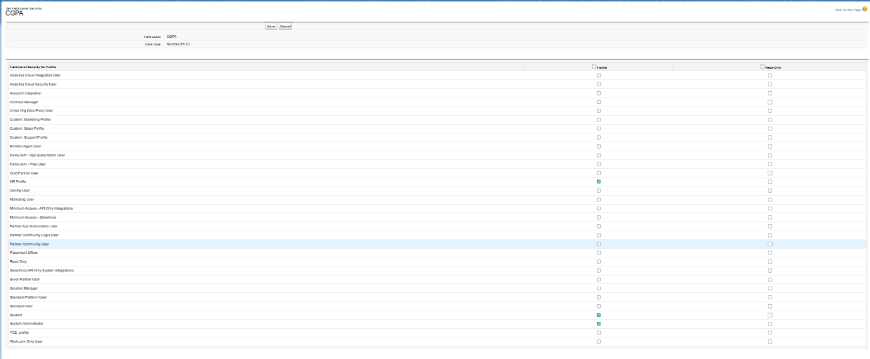

**5. Page Layouts**

**Procedure (step-by-step for each object):**

1. Navigate: **Object Manager → [Object] → Page Layouts → Edit (Default Layout)**
2. Click **Add Section** → name it **Header / Highlights**
   * Drag key fields (Name, Roll No, Company, Status) here
3. Add **Details Section** → drag remaining fields
4. Add **Related Lists Section** → drag related lists (Applications, Feedbacks, Internships)
5. Rearrange fields for clarity
6. Click **Save**

**5.1 Student Page Layout**

* Sections: Header (Name, Roll_No__c), Details (Department, Year, CGPA, Email, Phone), Related Lists (Applications, Feedbacks)  
  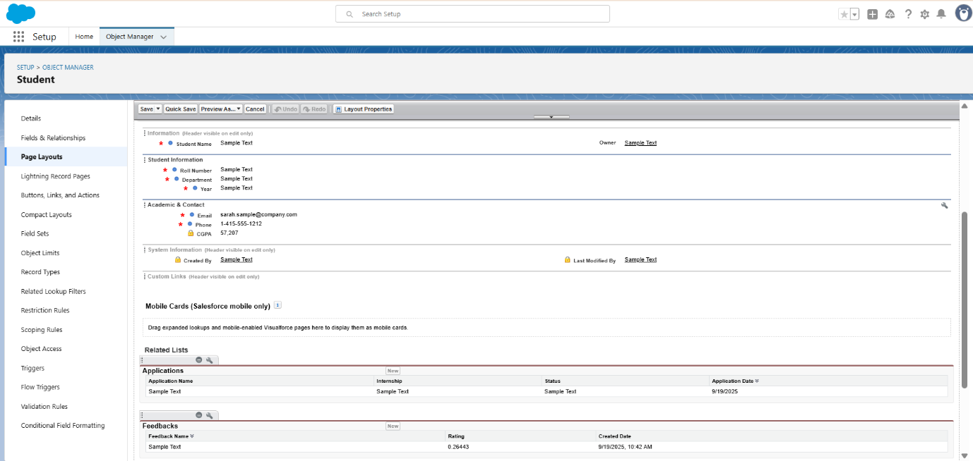

**5.2 Company Page Layout**

* Sections: Header (Name, Industry__c), Details (HR_Name__c, HR_Email__c, HR_Phone__c), Related Lists (Internships, Feedbacks)  
    
  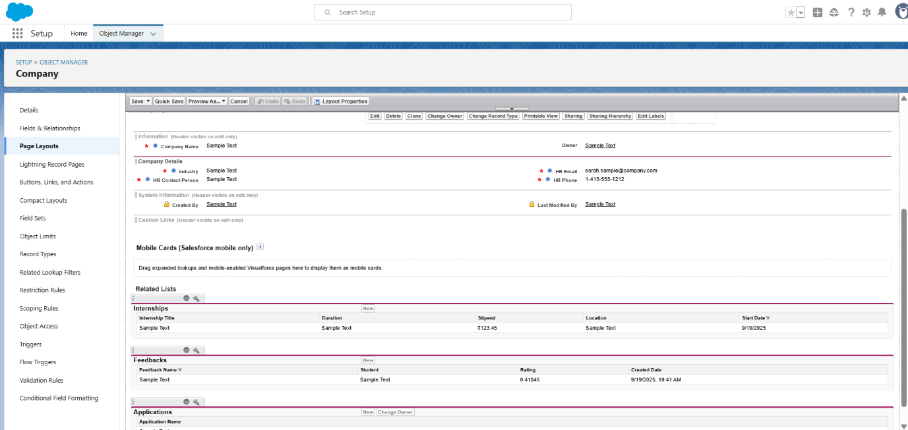

**5.3 Internship Page Layout**

* Sections: Header (Name, Company__c), Details (Duration, Stipend, Location, Start/End Dates), Related Lists (Applications)  
    
  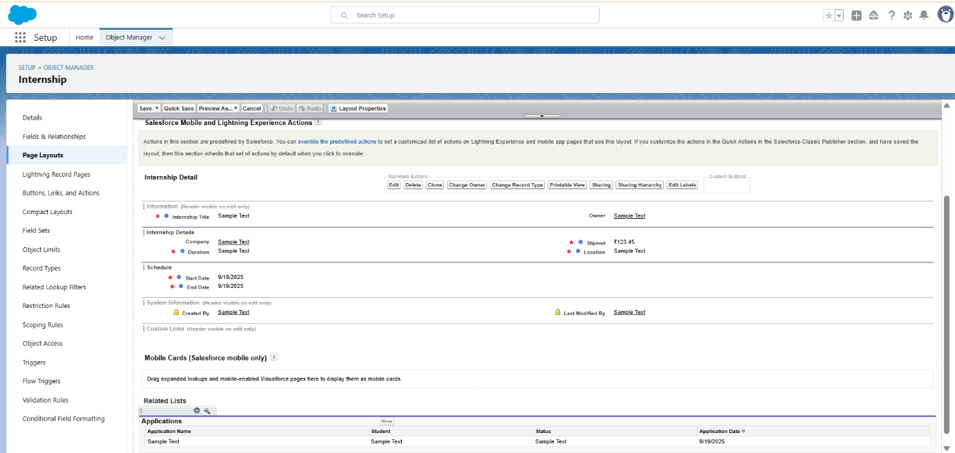

**5.4 Application Page Layout**

* Sections: Header (Name), Details (Student__c, Internship__c, Status__c, Application_Date__c, Remarks__c), Related Lists (History)  
    
  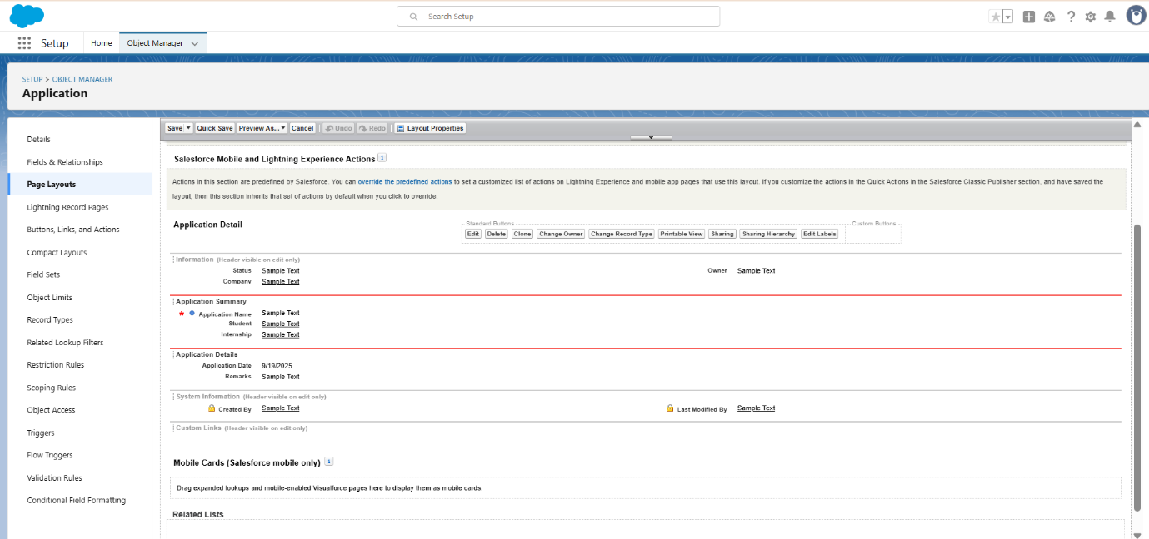

**5.5 Feedback Page Layout**

* Sections: Header (Name), Details (Student__c, Company__c, Rating__c, Comments__c, Feedback_Date__c)  
    
  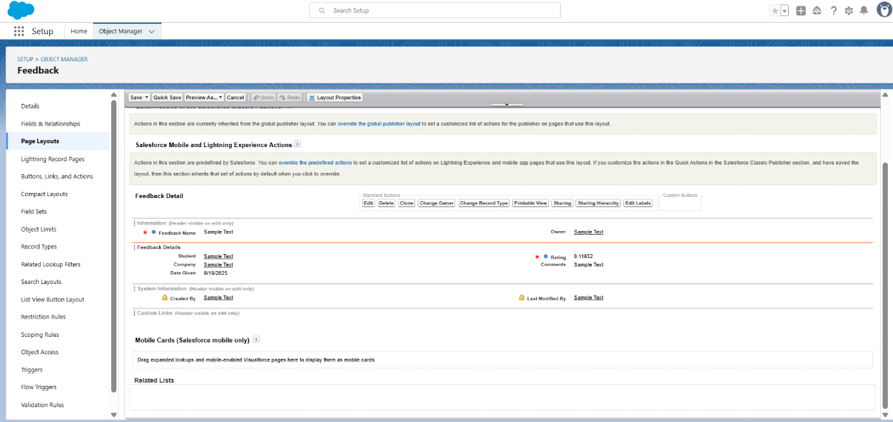

**6. Related Lists Configuration**

**Procedure:**

1. While editing page layout → scroll to **Related Lists** section
2. Drag related lists from palette → drop into layout
3. Click **wrench icon** → customize columns to show key fields (Application Name, Student, Internship, Status, Date)
4. Click **OK → Save**

**7. Compact Layouts**

**Procedure:**

1. Object Manager → [Object] → Compact Layouts → New
2. Add fields for quick view:

| **Object** | **Fields** |
| --- | --- |
| Student | Name, Roll_No__c, CGPA__c |
| Internship | Name, Company__c, Location__c |
| Application | Name, Status__c, Application_Date__c |

1. Set layout as **Primary → Save**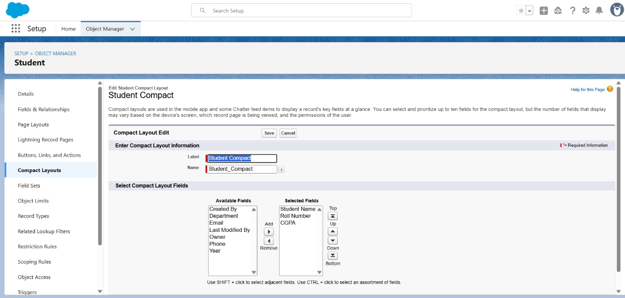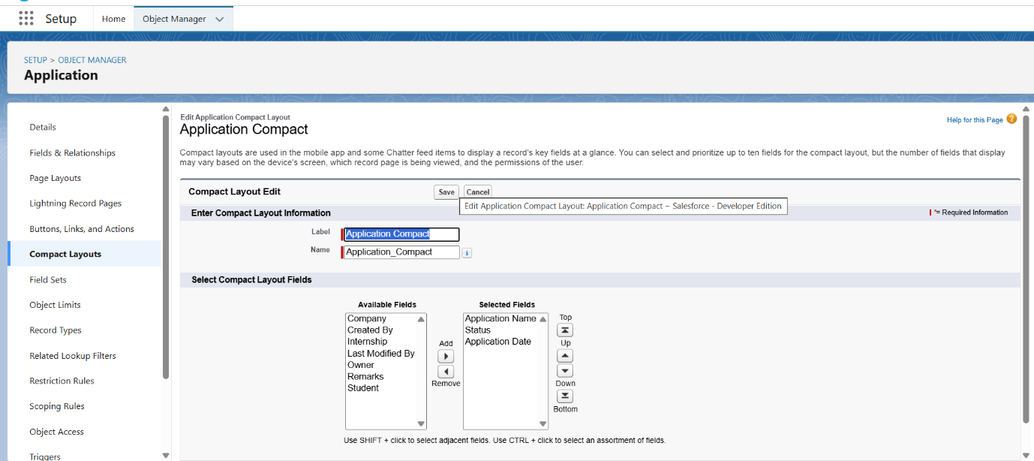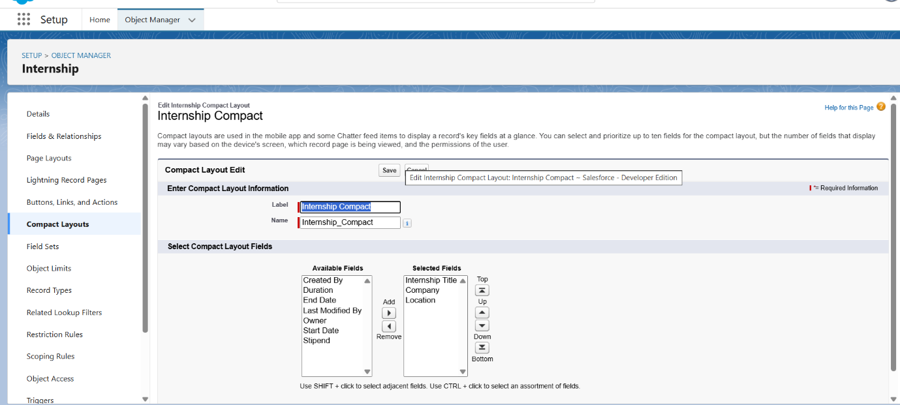

**8. Tabs Creation**

**Procedure:**

1. Setup → Tabs → New → Custom Object Tab
2. Select object → choose icon → Next → Save
3. Add tabs to Lightning App  
     
   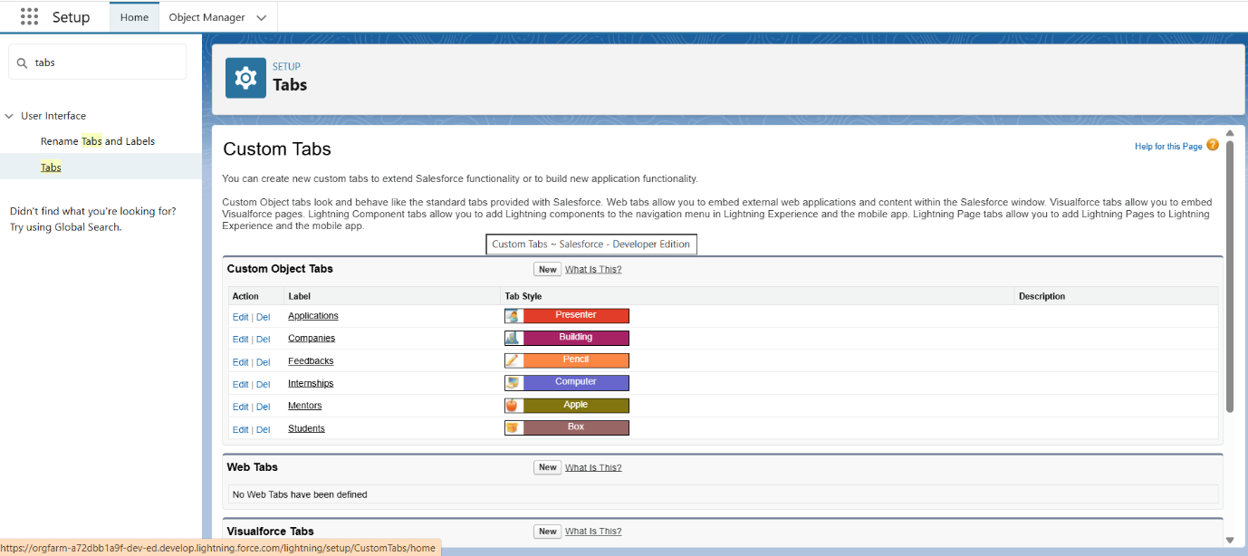

**9. Schema Builder Verification**

**Procedure:**

1. Setup → Schema Builder → select custom objects
2. Verify relationships:
   * Internship → Lookup → Company
   * Application → Lookup → Student
   * Application → Lookup → Internship
   * Feedback → Lookup → Student
   * Feedback → Lookup → Company
3. If any relationship missing → create via Object Manager → Fields & Relationships → New  
     
   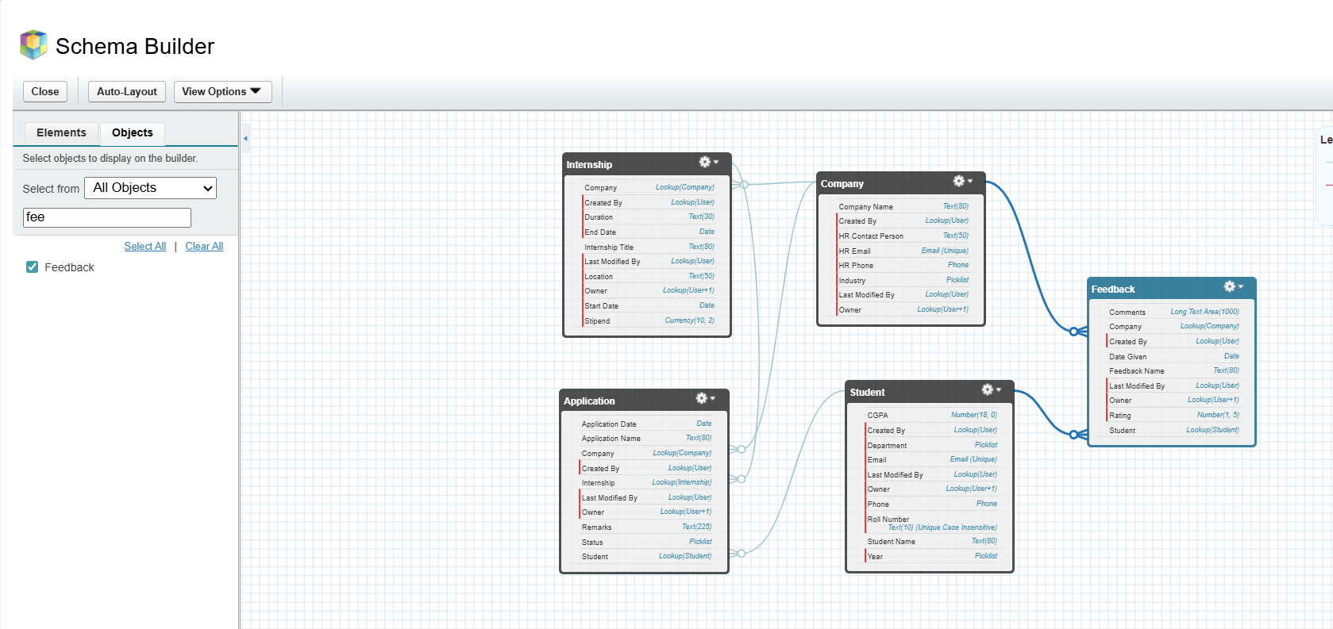

**10. Sample Data Creation**

**Procedure:**

1. Go to App → Object Home → New → Enter record details → Save
2. Create records for testing related lists and search

**Sample Records:**

* **Company:** TCS, HR Email hr@tcs.com, HR Phone 9988776655
* **Student:** Test Student, Roll No 21CSE045, Department CSE, Year 3rd, CGPA 7.85, Email test.student@test.com
* **Internship:** Salesforce Developer Intern, Company TCS, Duration 3 Months, Stipend 15000, Location Hyderabad
* **Application:** Student = Test Student, Internship = Salesforce Developer Intern, Status = Applied
* **Feedback:** Student = Test Student, Company = TCS, Rating = 4

**Verification:** Related lists populate correctly; search returns expected records